Legend of The Blade

Game Design Document  
Index

1. Index
2. Game Design
   1. Pitch
   2. Gameplay
   3. Mindset
   4. Uniqueness
3. Technical
   1. Controls
4. Level Design
   1. Game Flow
5. Graphics
   1. Style Attributes
6. Sounds/Music
   1. Style Attributes
   2. Sounds Needed
   3. Music Needed

Game Design

## Pitch

Legends of The Blade is an action-packed souls-like game, in which the player fights through terrifying monsters and dangerous traps in an attempt to save an island where the hell broke out. The game is focused on intense combat accompanied by a simple storyline. It is played from a top-down perspective and features pleasant and clear pixel art graphics.

## Gameplay

The goal of the game is obviously to defeat all the monsters and save the island. There should be multiple bosses to defeat, each getting harder and harder. In between the boss-fights the player is going to have a plenty of space to stock up on resources, level-up his class skills (more on that in Uniqueness) or to complete sidequests to find out more about the story in an open-world environment.

The game is going to be focused on the fighting mechanics, but they shouldn’t be too complex or overwhelming, so it’s not too tiring to fight a lot. That means both movement and weapon handling should feel easy, quick and accurate.

## Mindset

The player should feel like he is the only one who can save the island and that a lot of people’s lives depend on his fighting skills.

## Uniqueness

In the beginning of the story, the player chooses an artefact, and that artefact sets his ability class for the rest of the game, and there is going to be no way to change it (probably). Each class is going to be a bit different, mostly in the fighting mechanics. Classes could be: close-range, long-range, high-damage, high-speed etc. This should entertain the player throughout multiple playthroughs even though he will already know the story.

Technical

## Controls

The player will be able to set their own controls in the menu, but as a default setting, these are the controls:

1.Moving

**WASD** – basic movement - up, left, down, right

ROLL/DASH – possibility for dashing - **SHIFT** (*1)

2.Attacking

Basic attack – **LMB**

Empowered attack – **RMB**

Special ability (depending on weapon chosen) – **Q** (or somewhere around WASD)

Bow – **hold RMB** to draw the bow, release to shoot

Shield – When equipped with a one-handed weapon, you can have a shield as well, **holding RMB** to block incoming swings and projectiles at the cost of RMB attack

3.Interaction with the environment

Opening doors, looting chests, picking stuff up, going through dialog - **F**

*1 – the player can later “upgrade” his Roll to a dash, the difference being the player is invulnerable for the duration of the dash, and can dash through entities and onto elevation

- *Cuphead*

Level Design

## Gameflow

|  |  |  |  |
| --- | --- | --- | --- |
|  | **Earlygame** | **Midgame** | **Endgame** |
| **Pacing** | * Really slow pace, not many enemies at once * 1 boss with easy-to-understand mechanics | * A bunch of time to explore, loot and do side-quests in between bossfights * Multiple bosses with scaling difficulty | * Player sets the pace (decides whether to go loot, kill, explore) * Multiple hard bosses with different mechanics |
| **Objectives** | * Player understands basic mechanics, class system | * Player can adapt to multiple playstyles depending on the enemy he is fighting * Player is interested in the story and feels like “the hero” | * Player wants to kill all the bosses, but if he likes the story he can turn back to do sidequests… or whatever |
| **Challenge and difficulty curve** | * Easy to go through, game needs to lead the player and teach him | * Bosses aren’t too hard to defeat once you understand their mechanics * Time in between bossfights eases the pressure * Side quests are mostly about understanding the story and explore, aren’t too hard to complete | * Bosses have similar difficulty (really hard), but require different playstyles to defeat * The skilled players can just hunt bosses, the others can still complete sidequests or gather resources |
| **Player Guidance and Feedback** | * Player gets led by the game, the basic mechanics get explained in an *on-screen/in-environment* text | * Player says into what area he wants to go, but understands well where he can’t go, could go in the future * Less text cues since the player understands the game better | * The player mostly ignores the text, because he gets confident – needs to get more visual effect/audio cues * (possibly boss incorporating audio into mechanics???) |
| **Key Moments** | * Early game ends after player understands basic mechanics and kills the first boss | * End game starts after unlocking all sections of the map | * Side quests are done, player knows the story well, most of the skill-tree is unlocked, time to kill the last boss! |

Graphics

## Style Attributes

The Legend of The Blade has a 16-bit indie pixel art graphics and uses a color palette of 4 base colors for the environment. This color palette only consists of cold colors, so to balance that, there should be many *light sources/screen effects* with warmer tones (they will set the vibe of an area: the safer – the warmer).

](https://lospec.com/palette-list/hollow)

Although there are only 4 colors, the tilemaps are drawn with varying opacity of these colors, so it’s easier to draw them and to follow what’s happening on the screen in the chaotic bossfights.

Characters and other important on-screen objects are going to be drawn in different, much more vibrant, colors, so they are easy to see in the cold environment (or they will be outlined with bright colors).

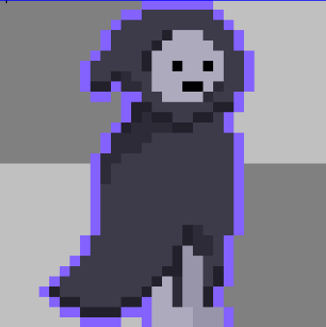

And if the game’s graphics designer will be brave enough, then many animations and effects should be added to enhance the feedback to the player. Both positive (landing an attack, leveling up,…) and negative (getting hit, falling, …) need to be taken very seriously.

To make the graphics designer’s life easier, the game could also make use of graphic effects made with code, for example flashing for getting hit, fading for dying and blurring to create animations in between different states.

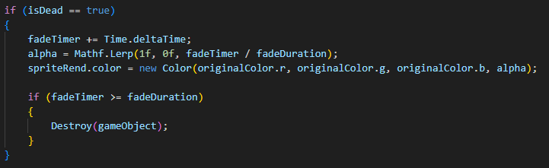

[Other ways to animate using code (and a lot more)](https://www.youtube.com/watch?v=2S3g8CgBG1g&t=160s)

Sounds/Music

## Style Attributes

The Journey will be accompanied by some retro, 16 - bit music, which the player can adjust in the setting, maybe different sliders for different types of sounds (music, sound, monsters, etc.)

Whenever nothing much is happening, you will hear calm music,

but whenever a player encounters an enemy, or let’s say enters a monster den, the music shifts into a faster one, simulating adrenaline. - *TerraTech*

Special sound for opening chests, equipping armor and weapons, walking, swinging and hitting, shooting, perishing of player and monsters, opening doors, etc.

## Sounds Needed

1. Effects
   1. Soft Footsteps (dirt floor)
   2. Sharper Footsteps (stone floor)
   3. Soft Landing (low vertical velocity)
   4. Hard Landing (high vertical velocity)
   5. Attacks (hammer, sword, wand/staff, etc.)
   6. Chest Opening
   7. Door Opening
   8. Acquiring a weapon or other loot
2. Feedback
   1. Hurtful “ugh”, “Oomph!” (taken damage)
   2. wooden “gong” (Blocking with a shield)
   3. bow string drawing, arrow shot, and landed
   4. magic sound
   5. player or monster dying
3. Talking
   1. Monsters growling when idle
   2. Monsters acknowledging the player
   3. Dialogue – *animal crossing*

Get music here https://freesound.org/

## Music Needed

1. Menu sound – whenever the menu is opened, the sound dampens
2. Slow-paced, nerve-racking “forest” track
3. Exciting “castle” track
4. Creepy, slow “dungeon” track
5. Happy outro track